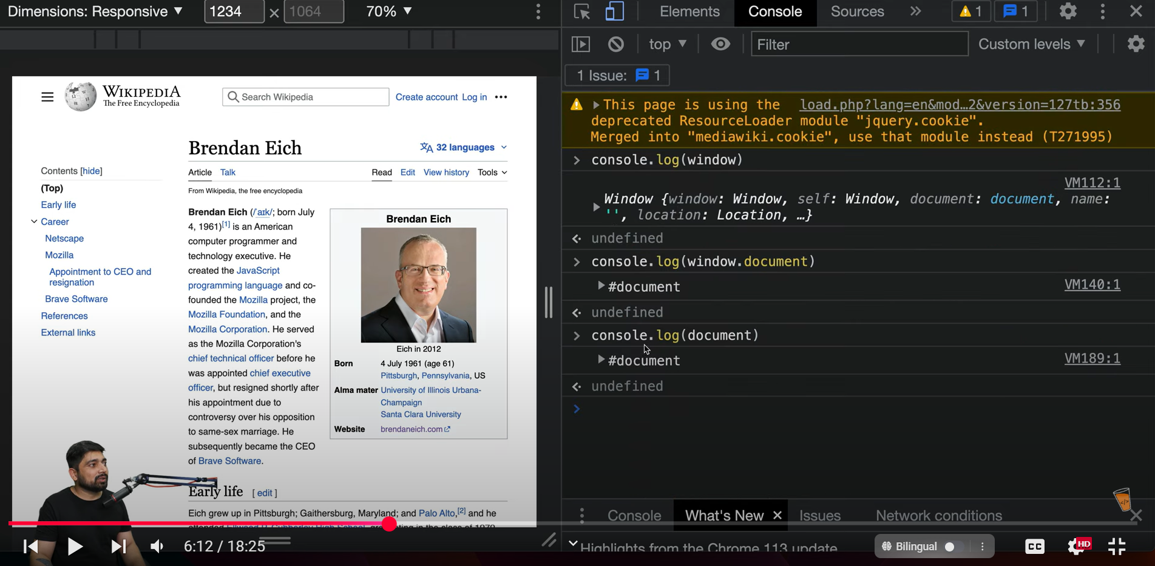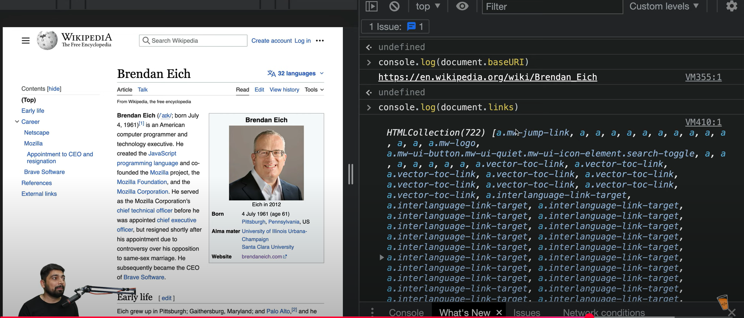

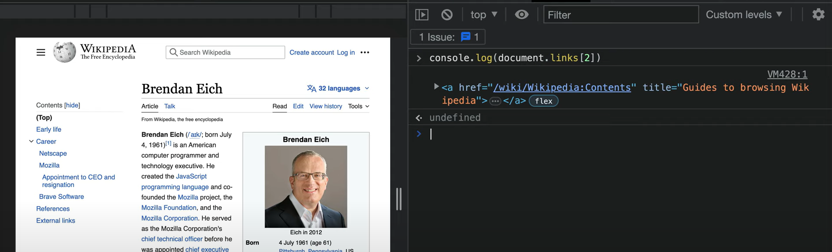

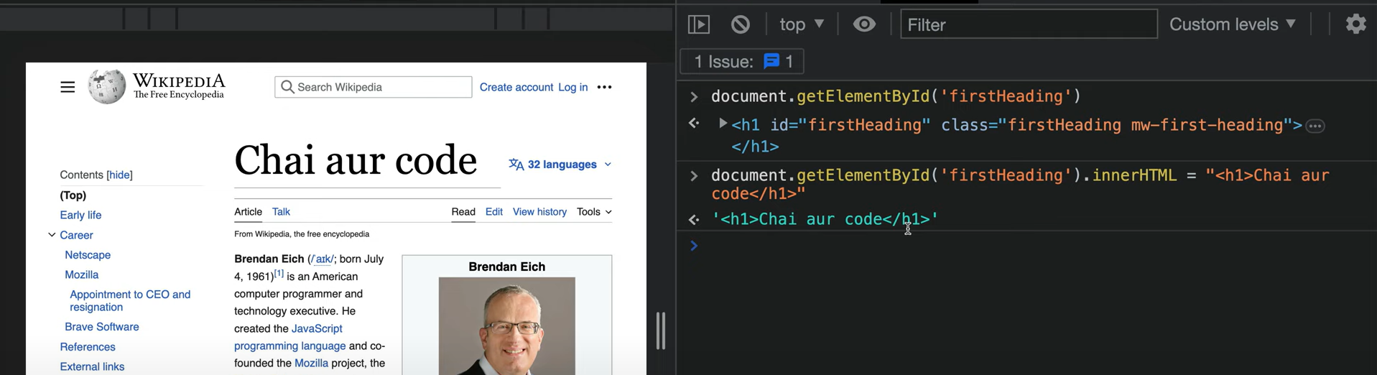

Video 32 started:

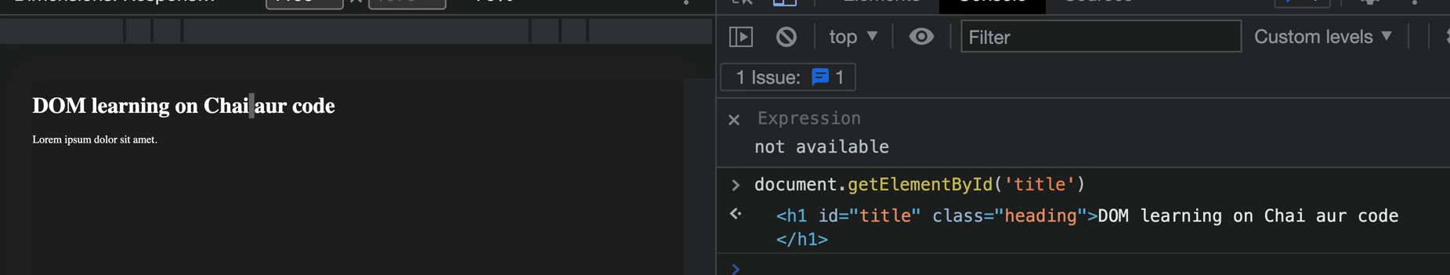

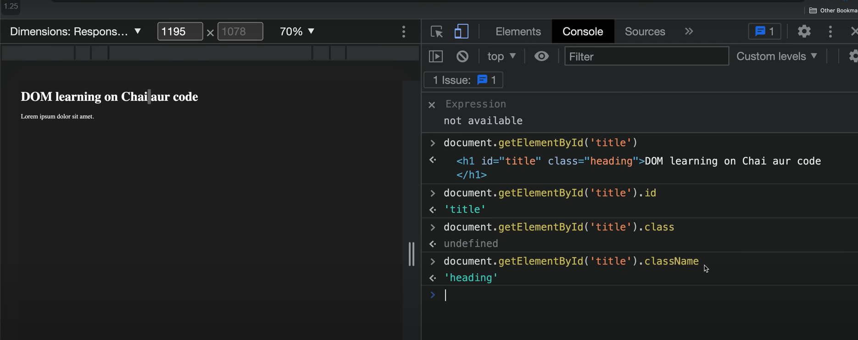

DOM ke andar className refer krte ha class ko always

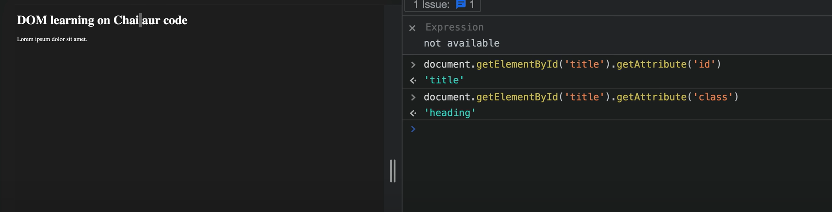

To get the attributes, pass the key to get the corres. Values

We can also set attributes:

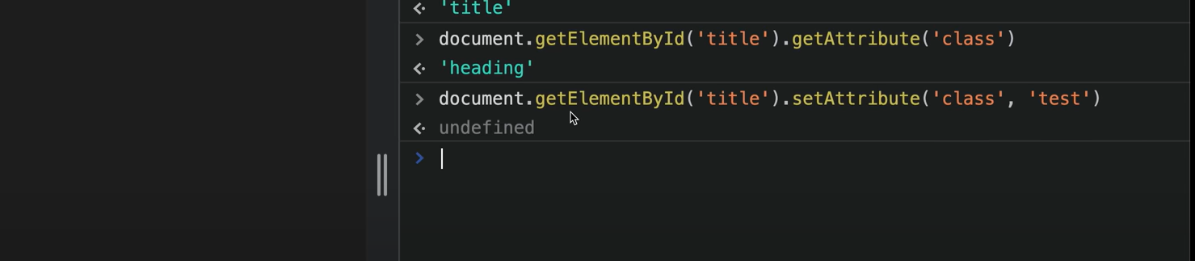



SetAttribute will overwrite the older values

‘test’ attribute ke instead we can also write ‘test head’

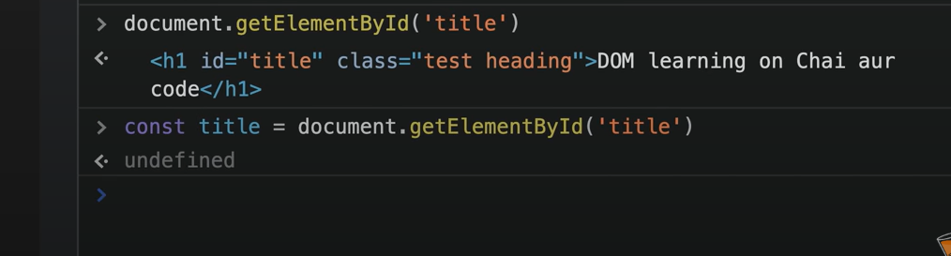

Applying style through dom:

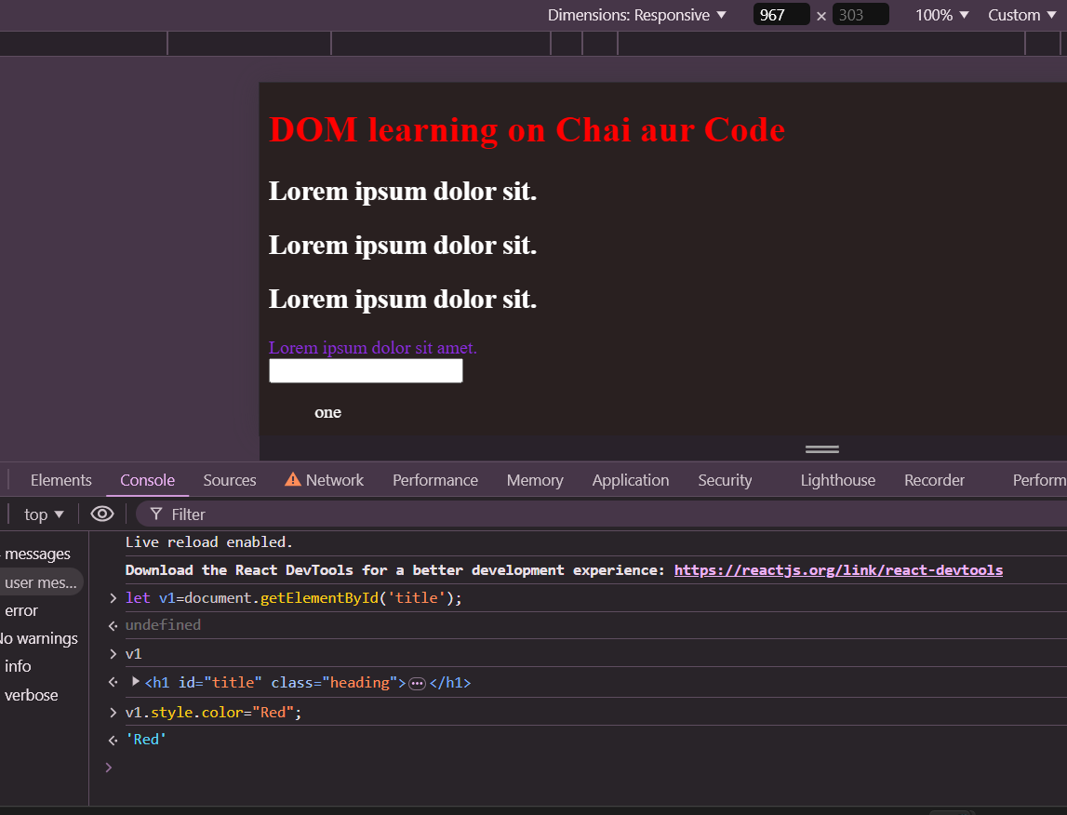

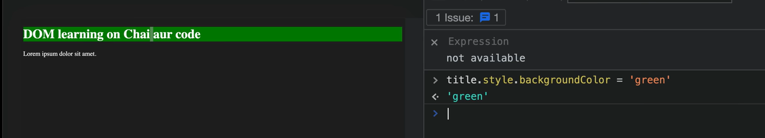

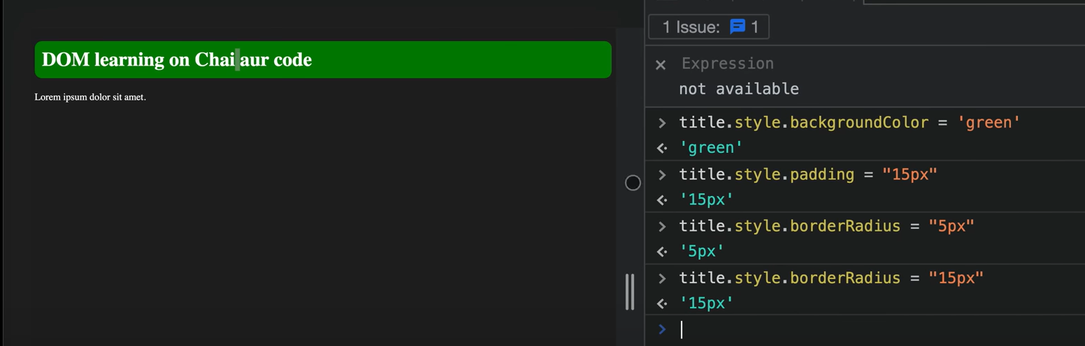

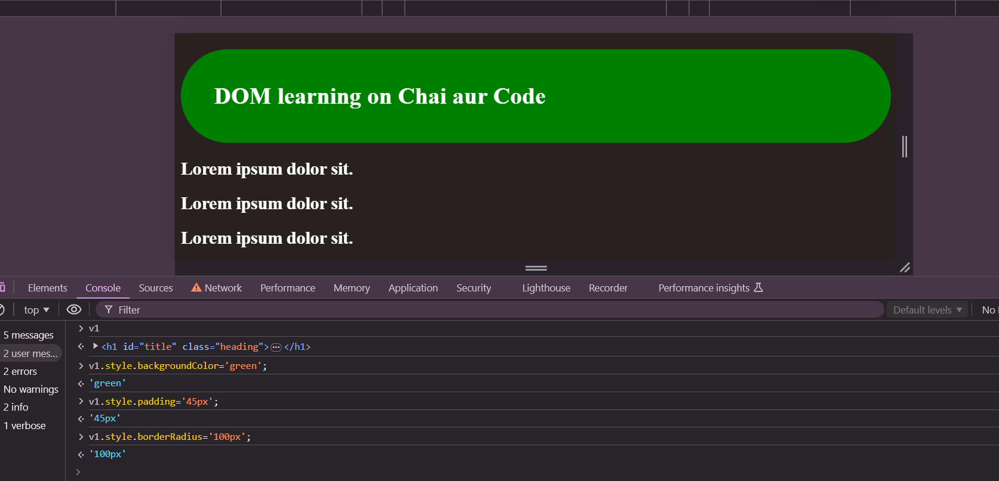

How to extract content?

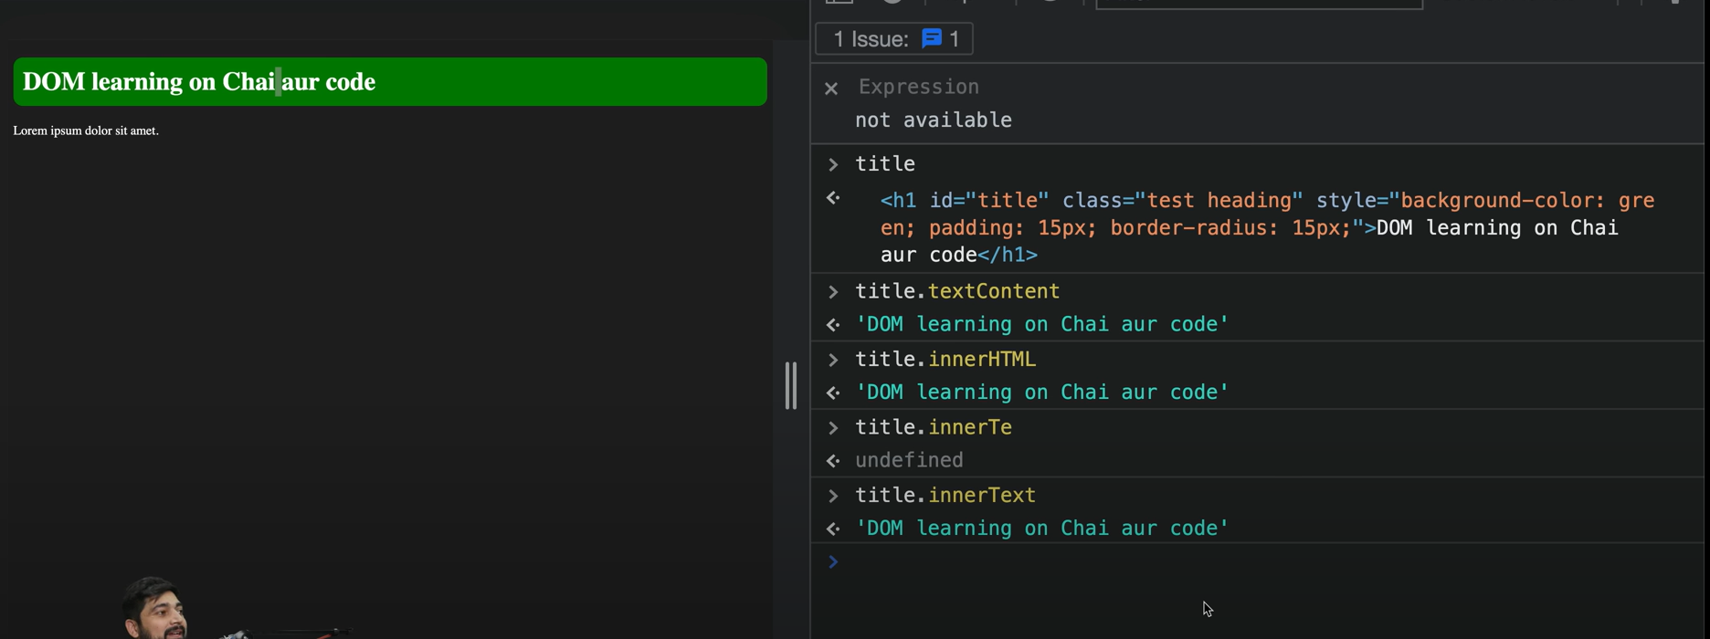

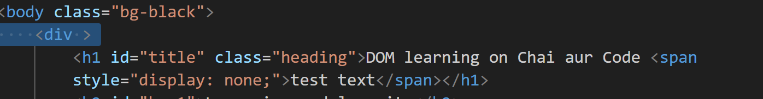

Display : none -> CSS property applied

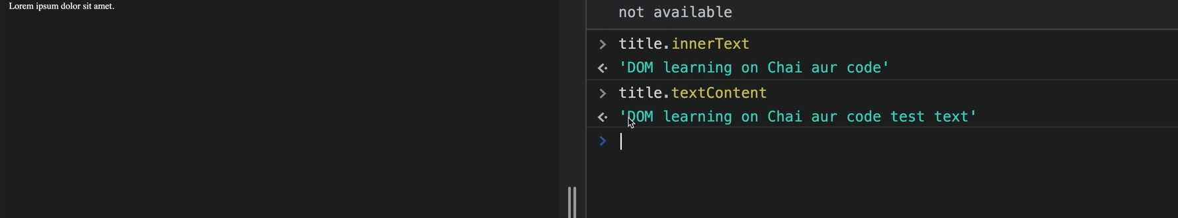

***textContent also showed up hidden content***

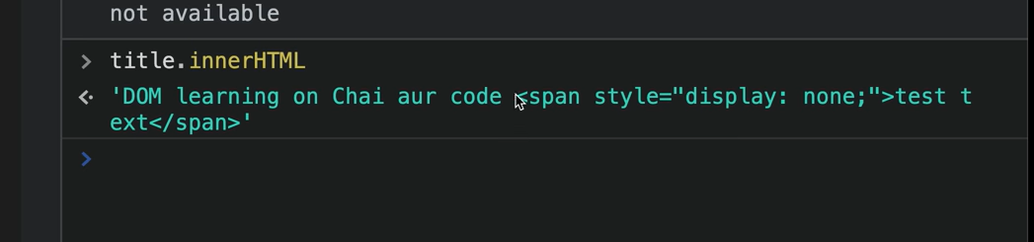innerHTML html value tags bhi de deta ha…baki 2 html tags ko support nhi krta

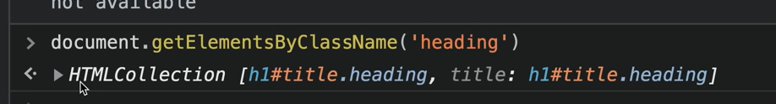

Selection through className returns HTMLCollections

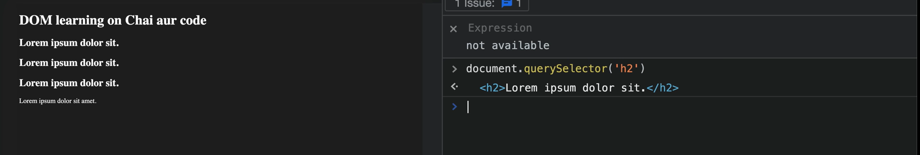

Query selector bas first h2 tag select krke dega

* To select id use # in queryselector

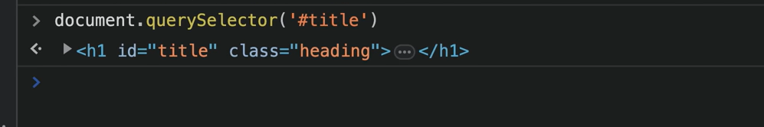

* To select class:

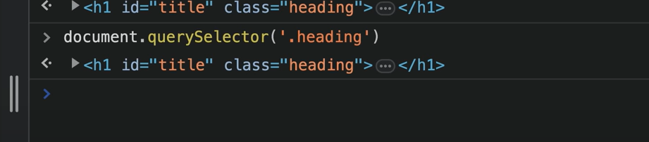

* ***All CSS selectors are supported in query selector:***

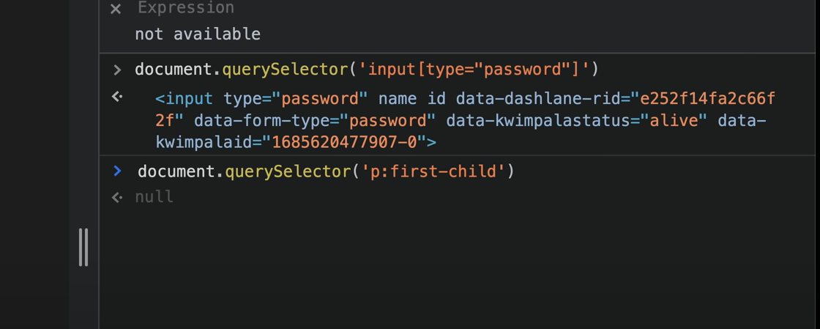

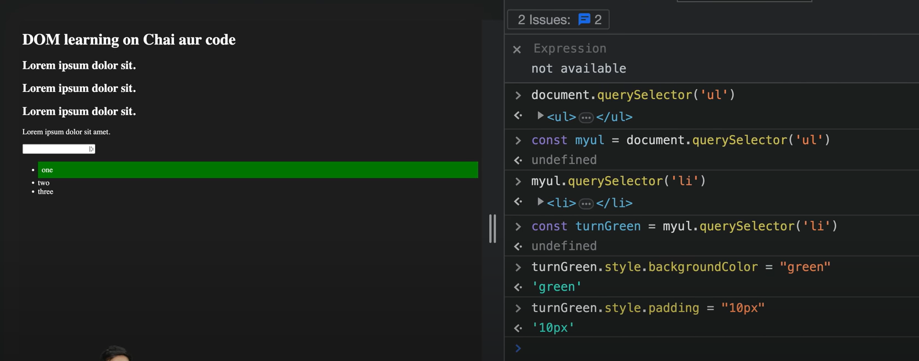

In above we have styled first list item

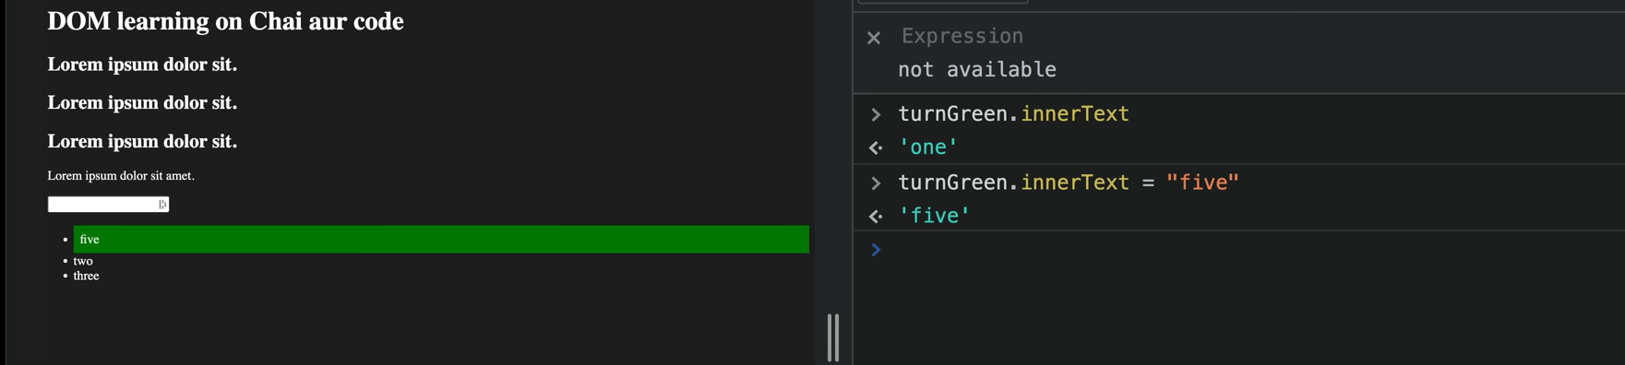

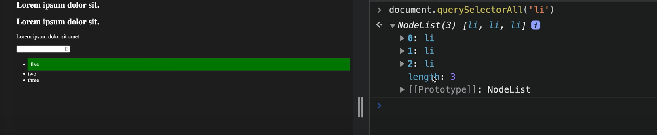

***querySelectorAll returns node list***

***node list is not pure arrays…so all properties of arrays are not applicable to them***

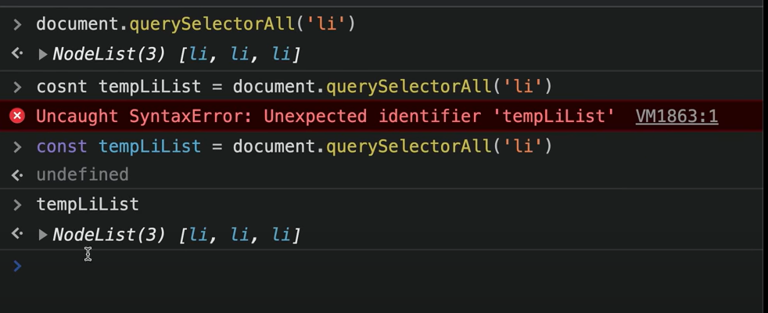

Prototype me jo fxns defined kisi elmnt ke only those can be applied

Coloring first elmnt using nodelist:

Nodelist me indexes has to be given for applying styling to elmnts

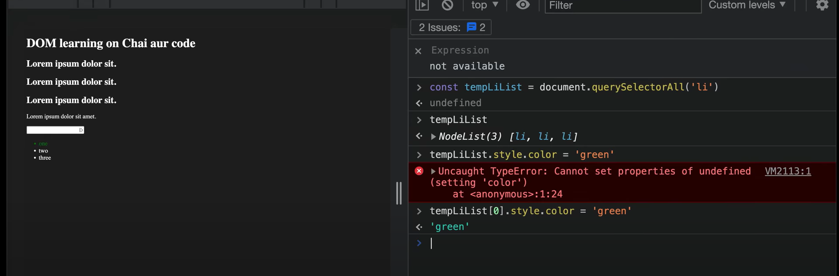

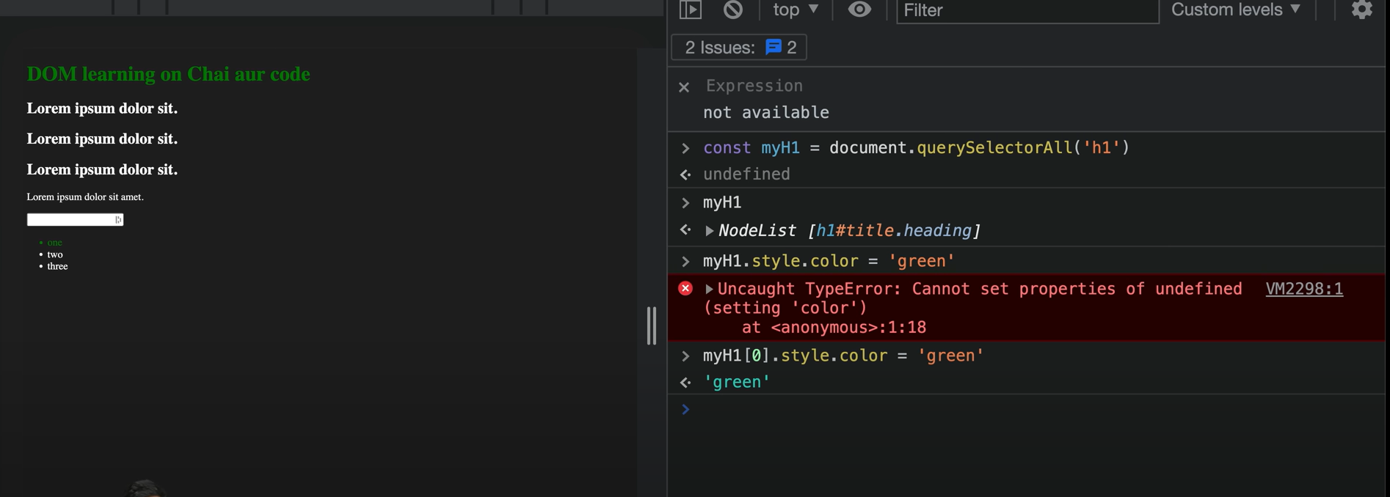

Using forEach loop in nodelist to style all list elmnts:

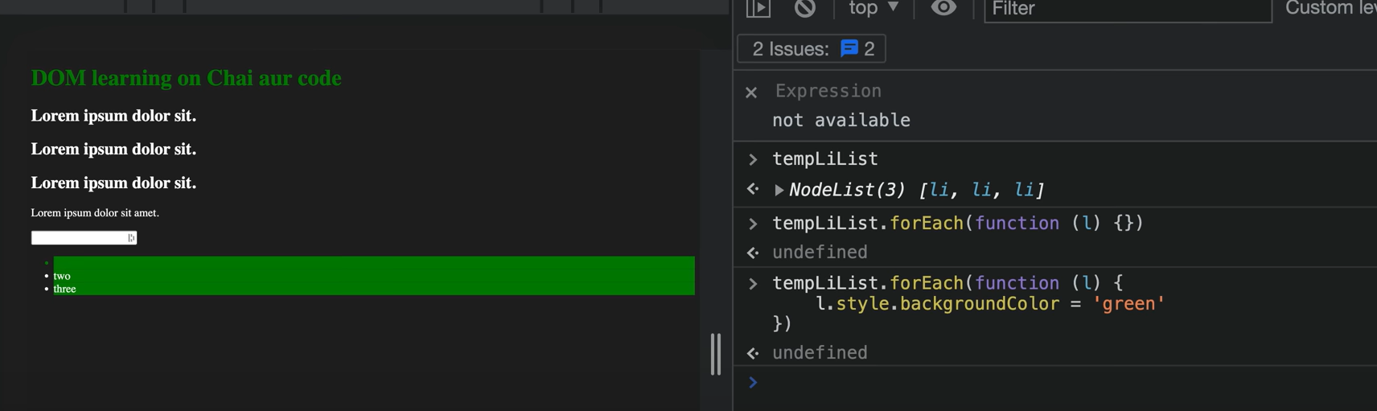

To use fxns like map etc on nodelist , first convert it to arrays

Note: HTML collections are diff. from nodeList.

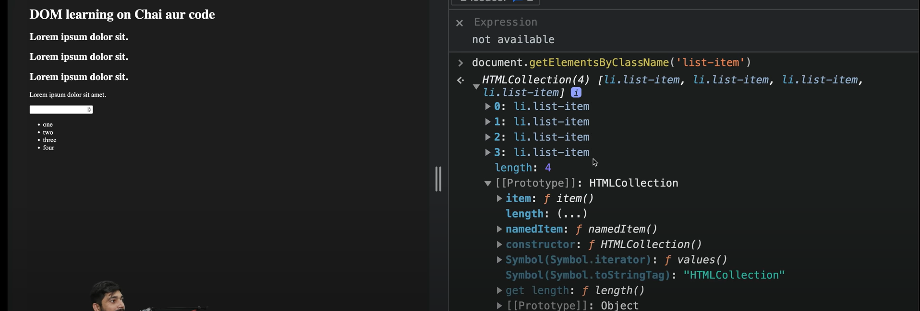

HTML collections have no option for looping

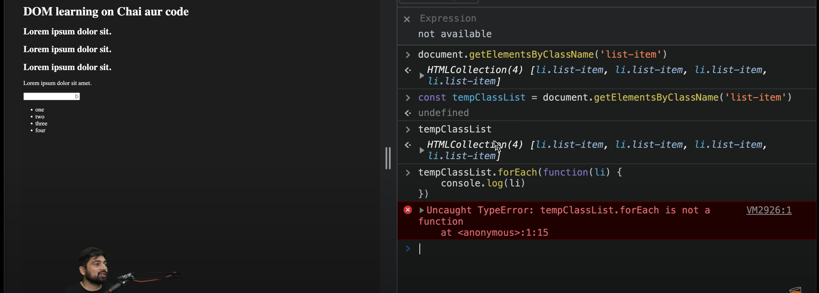

So we have to convert HTML collections to arrays to apply looping

Array.from() method can be used: kaha se mai array me convert kru

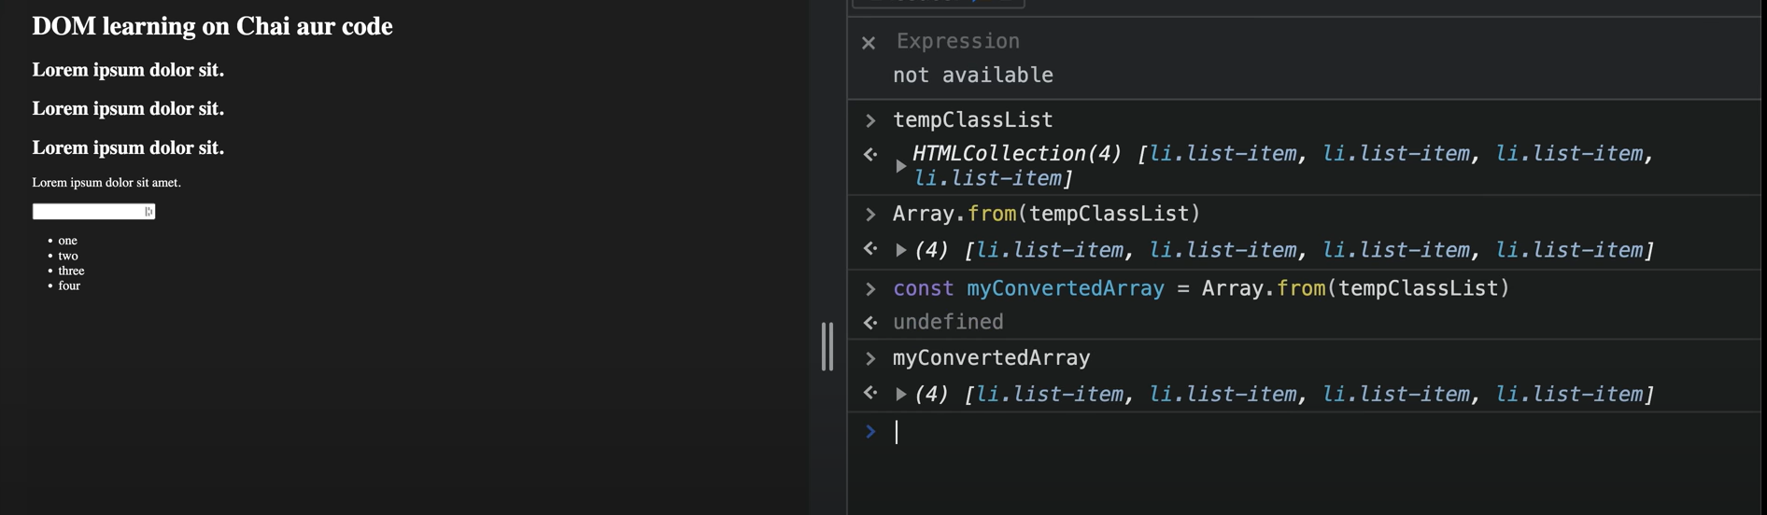

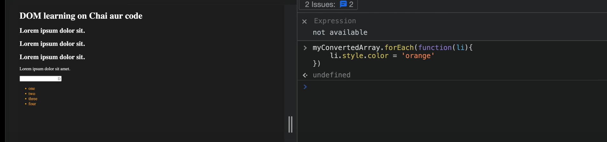

Doing fun on JS website:

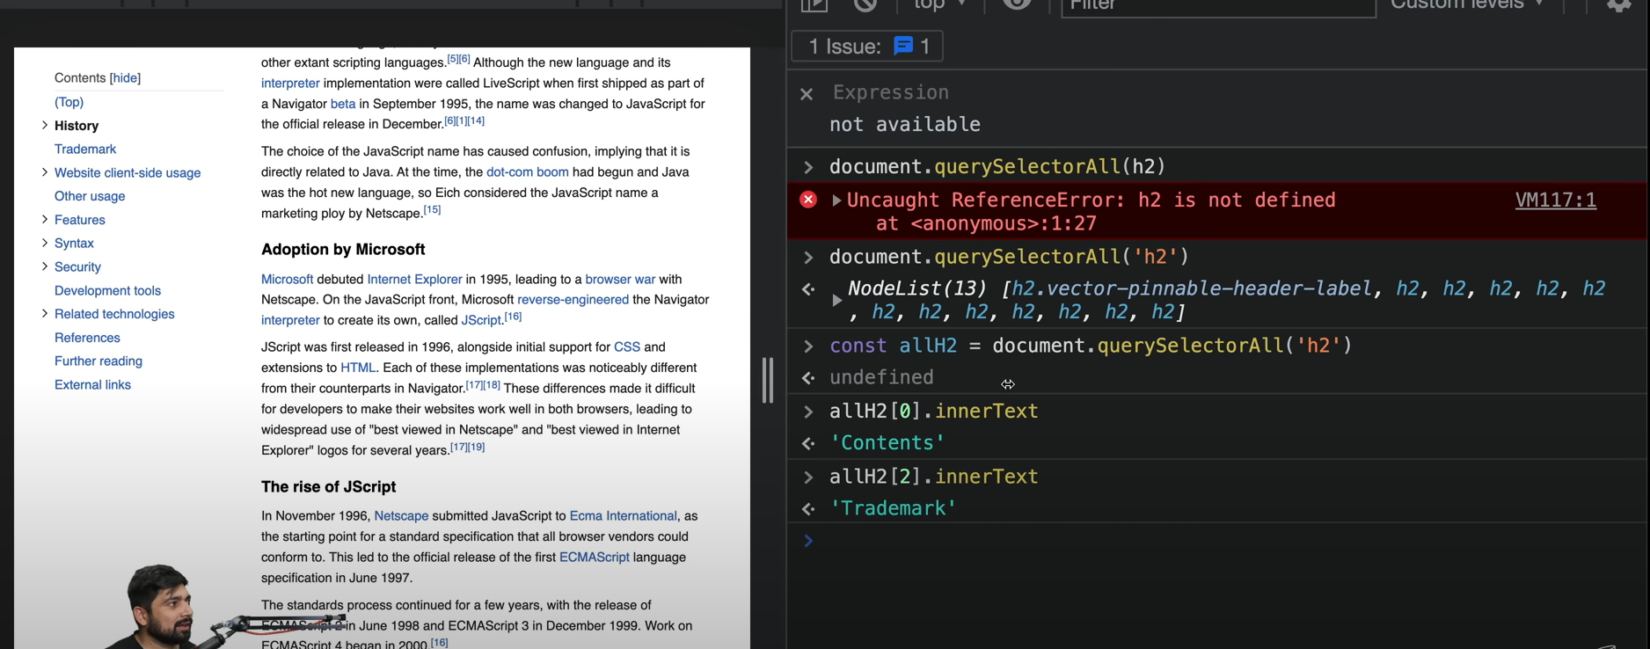

2.

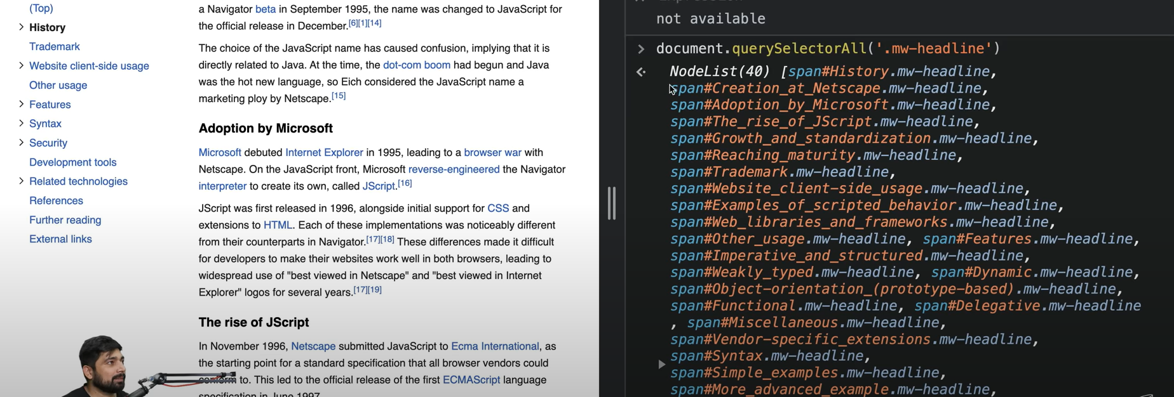

3.

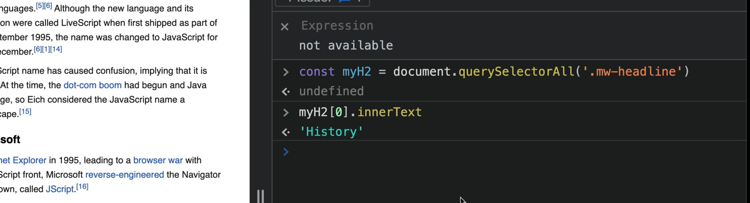

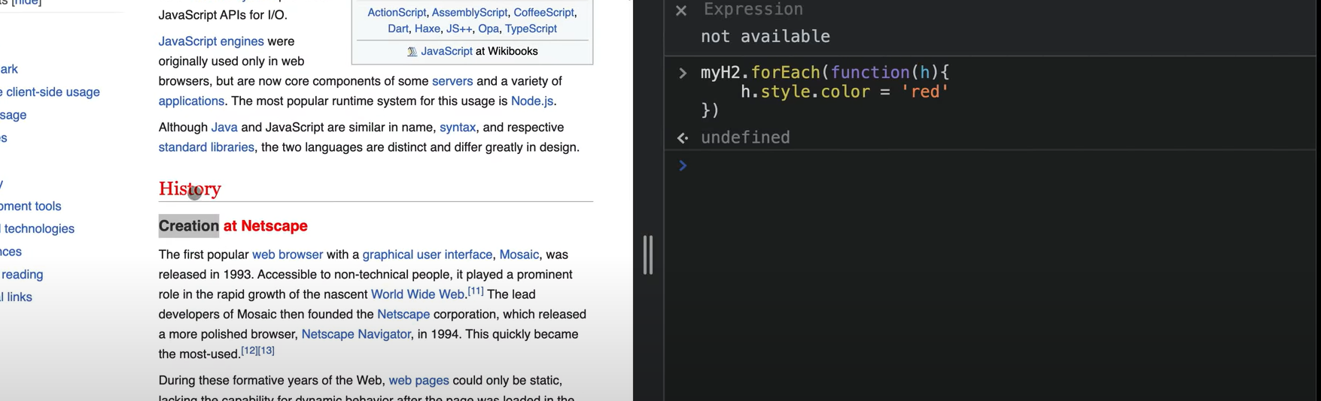

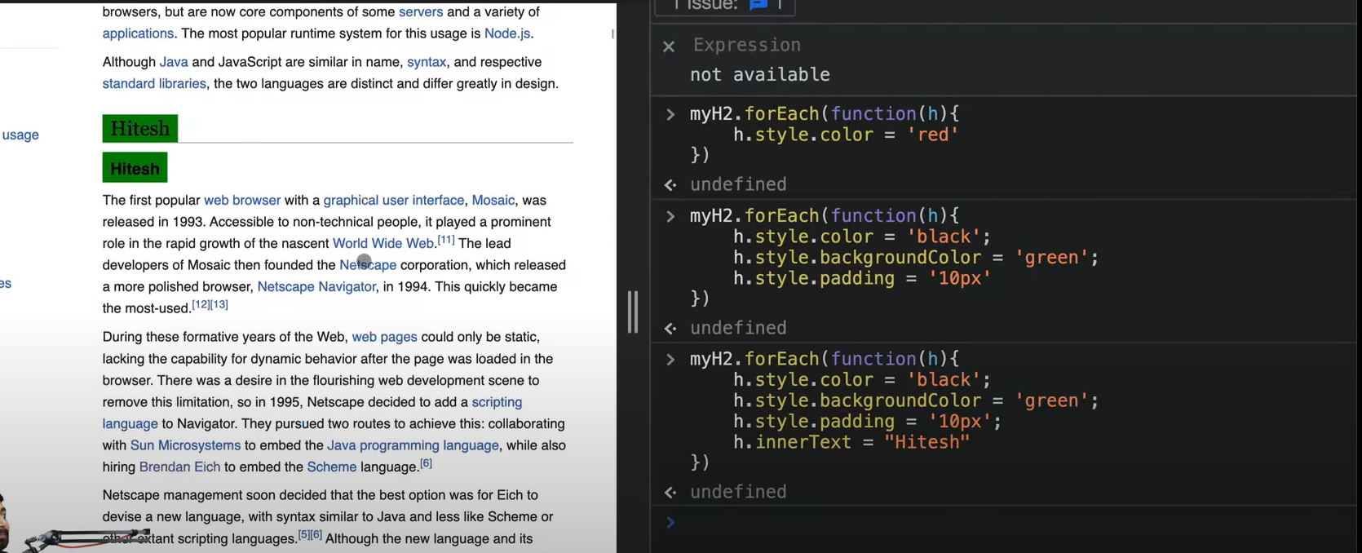

nodeList me forEach can be used but can’t be used in HTML Collections